DAFTAR ISI

HALAMAN JUDUL .............................................................................................. i LEMBAR PERSETUJUAN SKRIPSI ................................................................ ii HALAMAN PENGESAHAN .............................................................................. iii HALAMAN PERNYATAAN KEASLIAN SKRIPSI ....................................... iv KATA PENGANTAR ........................................................................................... v
HALAMAN PERNYATAAN PESETUJUAN PUBLIKASI
SKRIPSI UNTUK KEPENTINGAN AKADEMIS .......................................... vi ABSKTAK ........................................................................................................... vii DAFTAR ISI....................................................................................................... viii DAFTAR GAMBAR ............................................................................................ xi DAFTAR TABEL ............................................................................................... xii DAFTAR LAMPIRAN ...................................................................................... xiii DAFTAR NOTASI............................................................................................. xiv
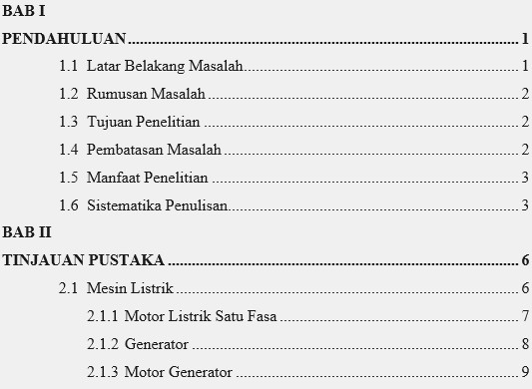

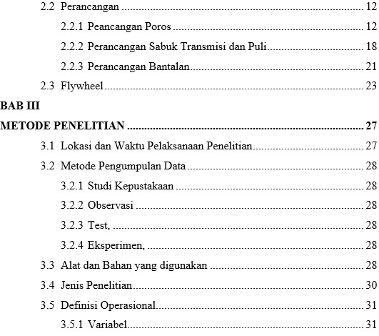

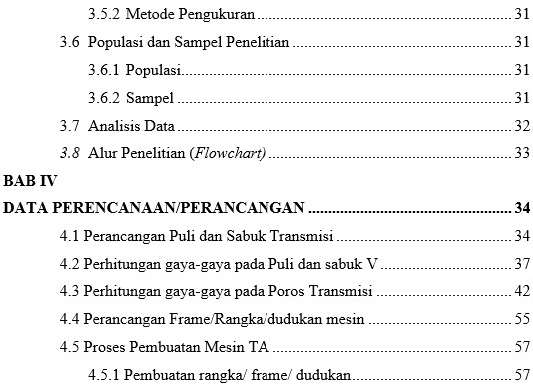

ix
POLITEKNIK NEGERI MANADO

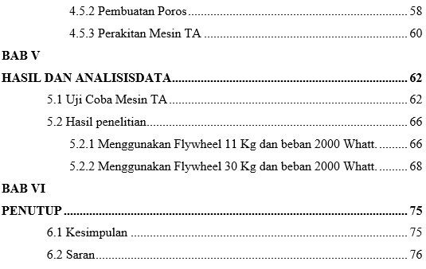

x
POLITEKNIK NEGERI MANADO

